**Creating Table**

**create table emp12( emp_id int not null primary key, emp_name varchar(25) not null , dept varchar(25) , sal int);**



**Inserting Values**

insert into emp12 values(1,'Anandu','Marketing','2400'); insert into emp12 values(2,'Ankit','Sales',2670); insert into emp12 values(3,'Chandrapal','Production',4321); insert into emp12 values(4,'Akansha','Designing',1790); insert into emp12 values(5,'Nismath','Marketing',1990); insert into emp12 values(6,'Megha','Production',3330); insert into emp12 values(7,'Chrissie','Sales',2370); insert into emp12 values(8,'Maddie','Sales',4200); insert into emp12 values(9,'Christina','Marketing',3990); insert into emp12 values(10,'Prem','Designing',2660);

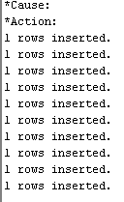

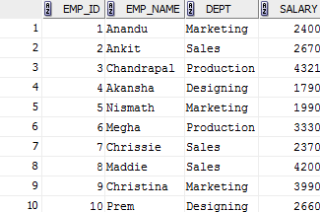

**SQL Queries Execution:**

1. select * from emp12;   
     
   
2. select emp_id,emp_name from emp12;  
     
   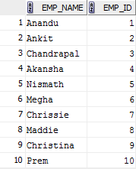
3. delete from emp12 where emp_id=10  
     
   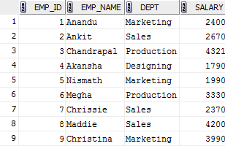
4. insert into emp12(emp_id,emp_name,dept) values(10,'Ryan','Marketing');  
     
   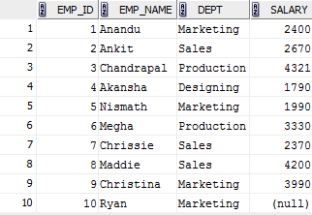
5. select * from emp12 where dept='Marketing';  
     
   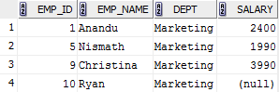
6. update emp12  
   set salary=4000  
   where salary is null;  
     
   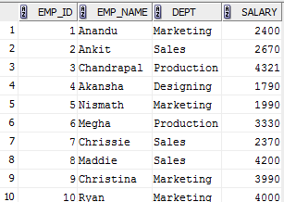
7. update emp12  
   set salary=1900  
   where emp_name=’Chandrapal’;  
     
   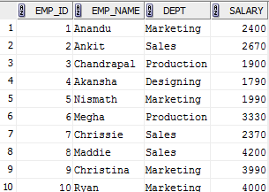
8. select * from emp12  
   where dept=’Marketing’ and salary>2000;  
     
   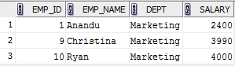
9. select emp_name from emp12 where dept='Sales' or dept='Marketing';  
     
   
10. select emp_name,dept from emp12 where salary between 2300 and 3000;  
      
    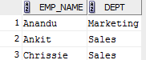
11. update emp12  
    set salary=salary+salary*12/100  
    where dept=’Production’;  
      
    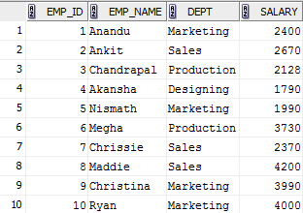
12. select emp_name from emp12 where dept='Sales' or salary<2000;  
      
    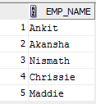
13. select emp_name as Employee_Name, emp_id as Employee_ID from emp12 where dept='Marketing' and salary>1000;  
      
    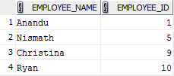
14. select * from emp12 order by emp_name;  
      
    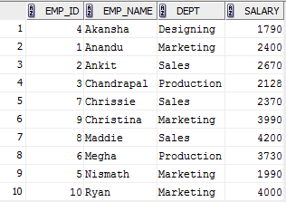
15. select * from emp12 order by salary desc;  
      
    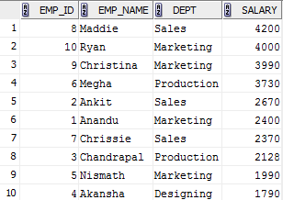
16. alter table emp12 modify (emp_name varchar(30));  
     **Before :   
     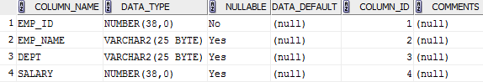  
      
      
    After :**  
    